**NIRMA UNIVERSITY**

**INSTITUE OF TECHNOLOGY**

**MECHANICAL ENGINEERING**

**Programmable logic controller (PLC)**

**LAB – 1**

**19BME134**

**Shrey Shah**

**Aim**

To understand the programming and architecture of PLC.

**Theory**

The programmable logic controller (PLC) is a solid state electronic device designed to replace electromechanical relays, timers, counters and sequences, by using a programmable memory for the internal storage of user oriented instructions for implementing specific functions such as logic sequencing timing, country and arithmetic control through digital or analog inputs and outputs, various types of machines or processes.

Major advantages of using PLC are as follows:

1. The PLC is a hardened industrial computer designed to withstand the harsh factory environment.
2. PLCs are reusable they contain a changeable program that eliminators extensive and component changes and that makes them cost effective
3. PLCs offer easy troubleshooting
4. PLCs feature easy installation and small size.
5. Increase productivity.
6. Ease of programming.
7. Ability to communicate with computer.

**Question 1**

Design different logic gates using PLC relay based instruction.

1. AND gate
2. OR gate
3. XOR gate

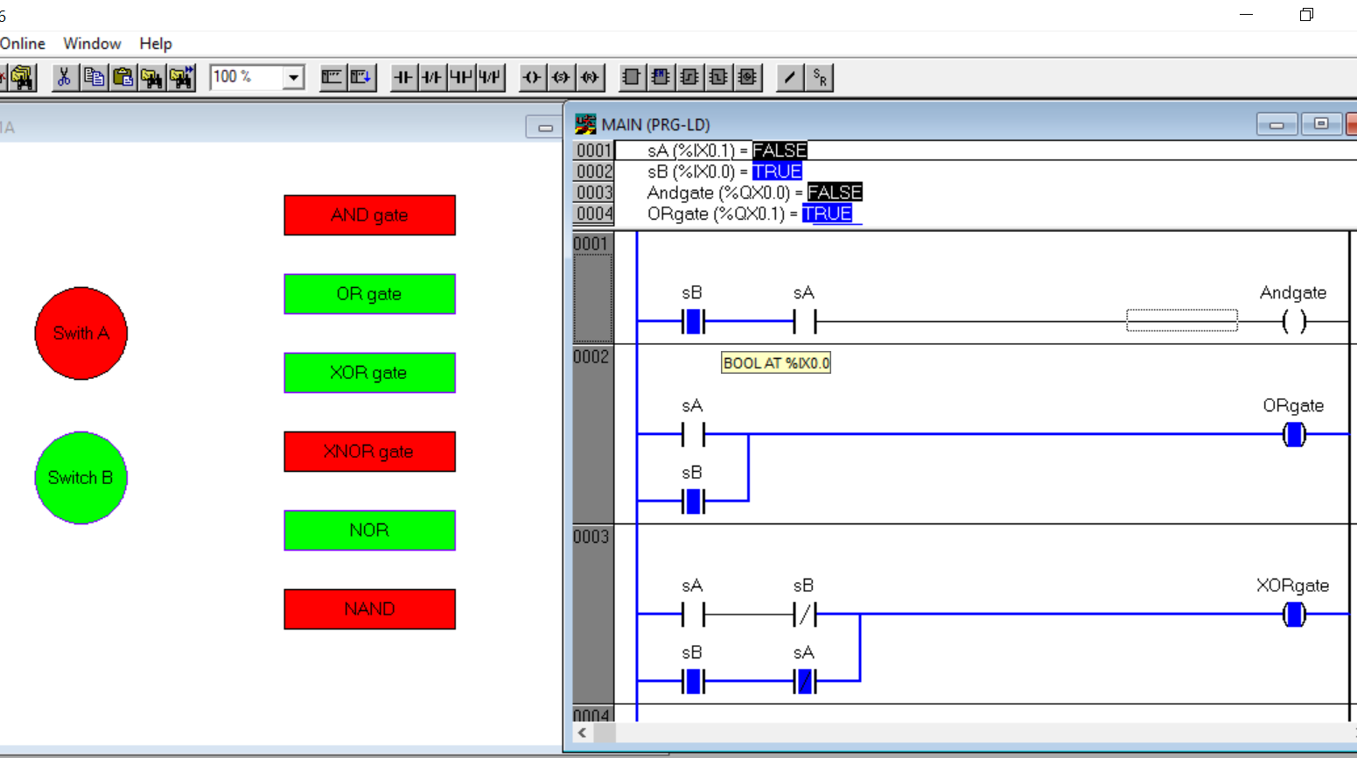

LOGIC -

AND

* Here, Switch A and B are both Normally open and are placed in series
* When only one of the switches is turned on, since the other one is off the bulb will not turn on either
* Only when both of the switches are turned on will the bulb will glow

OR

* In this case, the switches A and B are again normally open but kept in parallel combination.
* Even if only one of the switches is on, the circuit will be complete and the bulb will glow
* The bulb will not glow ONLY when none of the Switches are on

XOR

* The excusive or gate only responds when the conditions of both the switches A and B are similar
* When both the switches are either on or off the exclusive or will react and the bulb will turn on
* If either of the switch is turned on then the bulb will not glow

1. XNOR gate
2. NAND gate
3. NOR gate

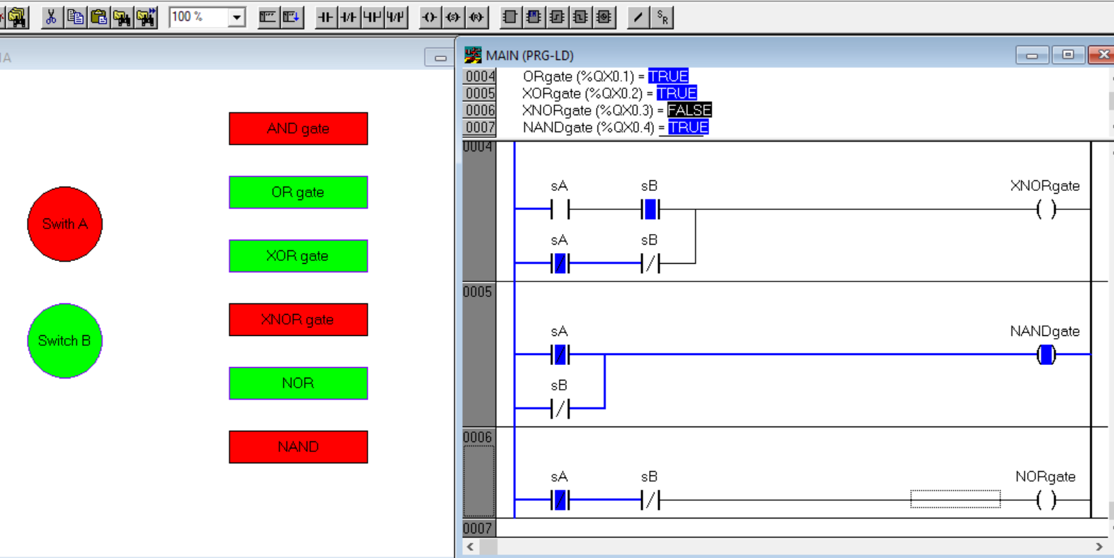

LOGIC

XNOR

* It is the opposite of XOR gate i.e the bulb turn on only when either of the switches are turned on.
* If the bulb senses similarity of switches then the bulb will not react and remain off.

NAND

* NAND gate is short form of Not AND which means the output of AND gate are negated.
* The bulb turns off only when all of the switches are turned on and the conditions in AND where the bulb is off, here it will remain on.

NOR

* Similar to OR gate, this is also a negated version but of OR instead of AND.
* In this gate the bulb will remain off in all the condition except for one where both the switches are simultaneously on
* In that condition the bulb will turn off as opposed to the general OR gate.

Logic tables -

|  |  |  |
| --- | --- | --- |
| A | B | output |
| 0 | 0 | 0 |
| 0 | 1 | 1 |
| 1 | 0 | 1 |
| 1 | 1 | 1 |

|  |  |  |
| --- | --- | --- |
| A | B | output |
| 0 | 0 | 0 |
| 0 | 1 | 0 |
| 1 | 0 | 0 |
| 1 | 1 | 1 |

OR Gate AND Gate

|  |  |  |
| --- | --- | --- |
| A | B | output |
| 0 | 0 | 1 |
| 0 | 1 | 0 |
| 1 | 0 | 0 |
| 1 | 1 | 1 |

|  |  |  |
| --- | --- | --- |
| A | B | output |
| 0 | 0 | 0 |
| 0 | 1 | 1 |
| 1 | 0 | 1 |
| 1 | 1 | 0 |

XOR XNOR

NAND NOR

|  |  |  |
| --- | --- | --- |
| A | B | output |
| 0 | 0 | 1 |
| 0 | 1 | 0 |
| 1 | 0 | 0 |
| 1 | 1 | 0 |

|  |  |  |
| --- | --- | --- |
| A | B | output |
| 0 | 0 | 1 |
| 0 | 1 | 1 |
| 1 | 0 | 1 |
| 1 | 1 | 0 |

**QUESTION 2**

An Alarm system has four inputs that go ON when some malfunction occurs. The system operates as follows. Design the ladder diagram for the same.

* If 1 input is ON, nothing happens.
* If 2 inputs are ON, Red Light goes ON.
* If 3 inputs are ON, an Alarm siren sounds.
* If 4 inputs are ON, Fire Department is notified

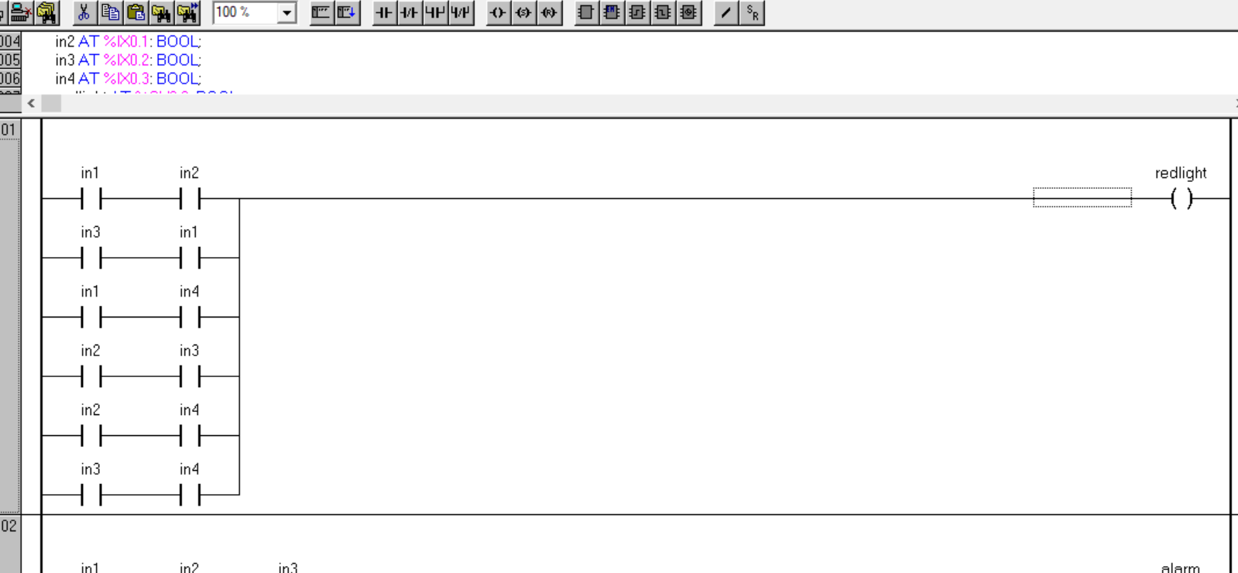

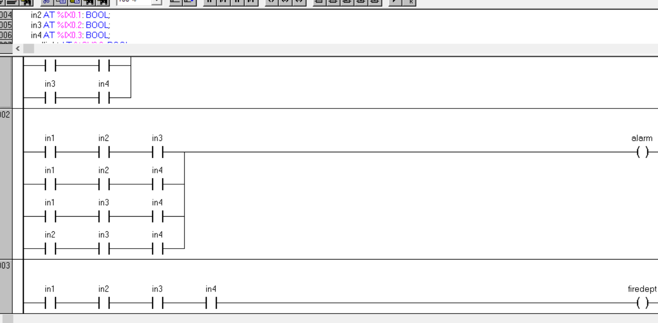

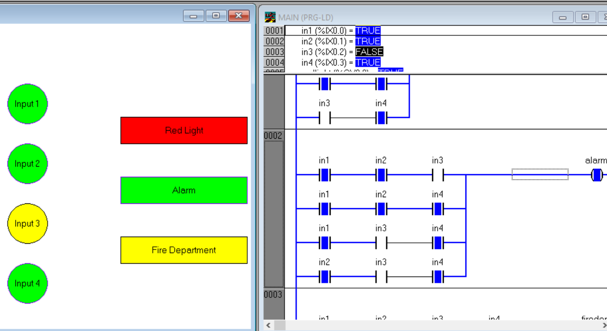

LOGIC

* In this question 4 different inputs are taken and based on the number of inputs that are on different outputs are turned on.
* If any 1 input is on, nothing will happen.
* If any 2 inputs are on then red alarm will go off. So based on the mathematical combination formula the number of possibilities for any 2 inputs being on are $C_{2}^{4}$, which is 6 possibilities.
* Hence 6 different combinations (in series) are clubbed together in parallel combination so that when any one combination it true the red light will start to glow.
* In the second case, any 3 inputs should be on. For that applying combinations again $C_{3}^{4}$, which equals 4 different combinations. So we put all the combinations in parallel where 3 different inputs are allotted to each combination. When any one combination becomes true the Alarm will go off.
* In the last case where all the inputs will be turned on there is only 1 such case so when all inputs are turn on the fire department will be called.

|  |  |  |  |
| --- | --- | --- | --- |
| INPUT | | OUTPUT | |
| Any 1 input is on | %ix0.0 | Nil | - |
| Any 2 inputs are on | %ix0.1 | Red Light | %qx0.0 |
| Any 3 inputs are on | %ix0.2 | Alarm | %qx0.1 |
| All 4 inputs are on | %ix0.3 | Fire Department | %qx0.2 |

**CONCLUSION**

* In this experiment we learnt about the TwinCAT software and how to operate it. We were taught the basic options in the software such as NO and NC switch parallel and series combination and visualization. After learning those we designed the simple logic gates such as AND, OR, XOR etc. along with visualizing it. The basic structure of the components and the ladder design naturally came along with it as a necessity. In the end we now have good rudimentary grasp on PLC.